**AI Adoption in Fitness Operations: Why Waiting Is the Costliest Option**

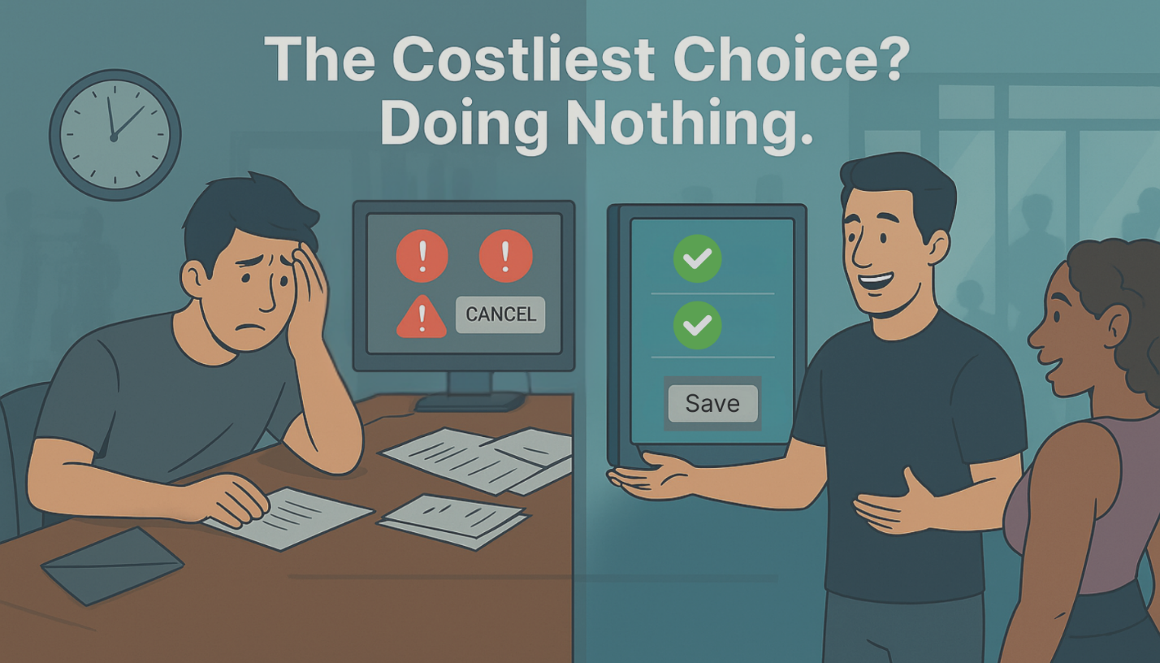

Every month your gym delays AI adoption, you're likely losing $5,000–$8,000 in preventable cancellations. And no—this isn't a future problem. It's happening now.

Fitness brands using DXFactor’s AI agents have seen 75% reductions in staff workload and a 5X member saves increase. Yet many operators still hesitate. Why?

**1. The Perception Gap: Personal vs. Enterprise AI**

| **Personal Use** | **Enterprise Use** | **Resulting Bias** |
| --- | --- | --- |
| Low stakes, instant convenience (shopping lists, playlists) | Perceived as complex, disruptive, and job-threatening | Leaders delay adoption despite proven ROI |

Modern **agentic AI** built for fitness clubs is neither experimental nor disruptive. It integrates into existing ecosystems, such as **ABC, Mindbody, ClubOS, and DAXKO,** in weeks, not quarters.

**2. The Three Hidden Costs of Inaction**

| **Cost Center** | **Typical Impact** | **AI Micro-Agent Fix** |
| --- | --- | --- |
| **Manual Admin Overhead** (cancellations, FAQs, class changes) | 20–30 staff hours per week, per club | **Member Concierge** handles 24/7 inquiries and bookings automatically |
| **Revenue Leakage** during cancellation attempt | $5K–$8K per month lost in dues | **Click2Save** serves customized save offers in <5 sec |
| **Churn from Poor Personalization** | Up to 50 % higher attrition in first 12 months | **Fitness Copilot & Insights2Action** deliver real-time nudges and program tweaks |

**3. Proven Results at Scale**

| **KPI** | **Pre-AI Baseline** | **After DXFactor Agents** |
| --- | --- | --- |
| Member saves per 100 cancellation requests | 0–2 | **8–10** |
| Staff time on repetitive tasks | 30 hr/wk | **<5 hr/wk** |
| NPS | 62 | **96** |

*Example: A Midwest athletic chain reduced data-analysis labor by 75% after unifying two MRMs and deploying decision dashboards.*

Want to see how much revenue you're leaking every month? Use our free ROI calculator or book a 30-min consult to map your first agent. [Start Saving Now.](https://dxfactor.com/cancellation-save-solution/#click_to_save_calculator)

**4. Why Jobs Aren’t at Risk—They’re Upgraded**

* **Task automation**, not role elimination: Agents handle the midnight questions so humans focus on VIP tours, upsells, and community building.
* **Skill amplification:** Staff gain instant access to data-driven scripts, cross-sell prompts, and sentiment alerts—no steep retraining curve required.

**5. Fast Track to ROI**

1. **Connect**: Secure API link to your existing club stack.
2. **Calibrate**: 7-day learning period on historical data and brand tone.
3. **Go Live**: First agent active in 2-4 weeks, typical payback <60 days.

**6. Action Checklist for Fitness Executives**

| **Next Step** | **Owner** | **Timeline** |
| --- | --- | --- |
| Identify one high-leakage workflow (e.g., cancellations) | Ops Lead | Week 1 |
| Pull baseline KPI (saves, hours, CSAT) | BI / Finance | Week 1 |
| Pilot a single micro-agent (Click2Save or Member Concierge) | DXFactor + IT | Weeks 2-6 |
| Compare KPIs, expand to adjacent use cases | Exec Sponsor | Weeks 7-12 |

**Final Word**

Your team already trusts AI to sort email and plan meals. **Trust it where the stakes—and returns—are far higher.** Every quarter of hesitation equals thousands in preventable churn and untapped capacity.

**Ready to quantify your own upside?** DXFactor’s AI MAP platform turns underperforming workflows into revenue engines—without new headcount or system upheaval. Let’s schedule a 30-minute outcome review and map your first agent to live production.

**SEO Title (≤ 60 characters):**

Why Fitness Clubs Can’t Afford to Delay AI Adoption

**Meta Description (≤ 155 characters):**

Delaying AI in gym ops costs thousands in churn & staff hours. Learn how DXFactor agents deliver results in <60 days—without system overhauls.

**Proposed URL:**

<https://www.dxfactor.com/ai-adoption-fitness-operations>

**UTM URL (for LinkedIn organic campaign):**

<https://www.dxfactor.com/ai-adoption-fitness-operations?utm_source=mjlinkedin&utm_medium=social&utm_campaign=ai_adoption_blog>